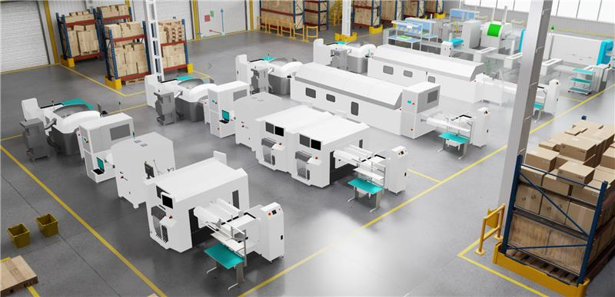
'RunningRobot' Competition

  - Problem Statement
This competition aims to explore and validate the generalization capability of embodied intelligence in complex industrial scenarios. We will challenge the adaptability of your embodied agent against changing environments and tasks in a realistic industrial environment. Imagine that you are in a busy electronics factory, with spacious workshops, various types of equipment, and multiple loading, unloading and placement points. Your embodied agent will embark on a critical mission: to execute a series of complex material handling tasks in different scenarios, adhering strictly to provided Standard Operating Procedures (SOPs), mirroring the expertise and flexibility of human operators.
We will provide five different 3D factory environments (provided in USD format). For each environment, a Standard Operating Procedure (SOP) will be delivered as a PDF document, integrates text and image-based instructions to clearly define the execution steps for specific tasks, such as identifying pickup and destination points and objects to move. These SOPs are your agent's guide, integrating both textual and image-based instructions to clearly outline every step: from identifying specific pickup and destination points to precisely recognizing and handling the objects to be moved.
Your ultimate goal is to demonstrate an embodied AI agent capable of understanding, interpreting, and executing complex, multi-step material handling tasks from human-readable SOPs, thereby proving its potential to revolutionize factory automation and efficiency.

  - Evaluation Metrics
Your embodied AI agent will be evaluated across two key dimensions: Performance and Innovation. Think of it like a real factory worker – we're looking for reliable, efficient and clever solutions!
Performance (60% of Total Score):
This dimension assesses how effectively and reliably your robot completes the assigned tasks. A dedicated scoring program will objectively measure several critical aspects:
- Task Completion: How successfully the agent finishes the tasks.
- Efficiency: How quickly the task is completed.
- Safety: The robot should operate safely within the factory environment, avoiding collisions or abnormal acceleration.
The scoring program will be openly shared on GitHub. Please feel free to use it to test your performance before submission.
Innovation (40% of Total Score):
This criterion evaluates the extent to which a submission introduces novel, original, or significantly enhanced methods, algorithms, architectures, or conceptual frameworks that advance the state-of-the-art in embodied AI. Novelty can manifest in various forms, including algorithmic, architectural, and integration innovations, as well as theoretical contributions.
Your submission will be rigorously evaluated by a diverse panel of experts, comprising senior academic researchers and experienced industry professionals. To ensure your innovative contributions are fully recognized, we strongly encourage you to include a dedicated 'Novelty Statement' within your submission. Each submission will be reviewed by at least three judges, for a balanced and objective assessment.
Evaluating Details
There are 5 different tasks, they will be evaluated based on three dimensions: Completeness, Timeliness, and Safety. The maximum scores are 10, 15, 20, 25, and 30 points, with target coordinates for each level dynamically read from their respective scene map files.
Scoring Breakdown:
The total score consists of two independent parts, each contributing half of the maximum score:
- Successful Departure (50% of total score):
  - Condition: The object moves more than 1 meter in either the x or y direction.
  - Assessment: If this condition is met, it is considered a successful departure, and full points for this part are awarded.
- Successful Arrival (50% of total score):
  - Condition: The object's planar position (x, y coordinates) is less than 0.8 meters from the center of the target table.
  - Assessment: If this condition is met, it is considered a successful arrival, and full points for this part are awarded.
Safety Deduction:
- If any collision occurs during the entire task process, 5 points will be deducted from the total score.
Timeliness Consideration:
- In cases of a tie in total scores, the solution with a shorter completion time will be considered superior.
  - Data Source
The factory scenes and SOPs can be downloaded [here]. You will be provided a MuJoCo repository at GitHub to start with, designed to assist with basic tasks like locomotion and grasping. While this resource is available, participants are welcome to pursue alternative

  - Submission requirements
To ensure a smooth evaluation process, please adhere to the following guidelines for your submission:
- Code Submission
- Reproducibility: It's crucial that your submitted code is fully reproducible. This means our evaluators should be able to run your solution and replicate your reported results without any issues. Please include all necessary dependencies and instructions to make this process as straightforward as possible.
- Technical Report
Please provide a comprehensive technical report, which can be either a README.md file or a PDF document. This report should cover the following sections:
- Technology Description: Clearly describe your methodology and the implementation details of your solution. If you utilized any third-party libraries or open-source algorithms, please specify them here.
- Novelty Statement (Highly Recommended): We strongly encourage you to dedicate a distinct section to articulate the unique aspects of your solution. Explain how your approach differs from and advances the current state-of-the-art, referencing relevant prior work to provide context. This is your chance to shine!
- Results & Analysis: Present both your quantitative and qualitative results in a clear and concise manner. Discuss the performance, highlight the strengths, and acknowledge any limitations of your approach.
- Video Demonstration (Optional)
- While not mandatory, a video demonstration showcasing your robot executing tasks within the simulation environment would be incredibly helpful and appreciated! It's a fantastic way to bring your solution to life.

